

**Master’s Degree in Computer Science**

**Academic year 2023/2024**

**START-UP IN ICT**

**Prof. Fabio D’Alessi**

Written by Michael Amista’

**Contents**

**1 Introduction** 3

**2 Entrepreneurs** 5

**3 J-Curve, TRL, Start-ups** 7

**4 Problems and Solutions** 11

4.1 Problem/Solution Fit 15

4.2 Product/Market Fit 18

4.3 Laboratory for Problem/Solution Fit 23

4.4 Laboratory for Product/Market Fit 28

**5 Scaling Up** 30

**6 Business Modeling** 32

6.1 Pipes and Platforms 42

6.1.1 Linear BM: Pipes 42

6.1.2 Platforms 43

**7 Laboratory for the Pitch** 48

**8 Equity** 51

**9 Incorporate a company** 54

**10 Venture Funding** 57

# **1 Introduction**

Course Overview:

1. Introduction to Entrepreneurship / Start-Ups
2. Innovation Vectors
3. Running a Start-Up
4. Building your Start-up

Every university has 3 fundamental missions:

1. Scientific research
2. High education / Teaching
3. **Bring everything to the public** **=** **Progress** (To share culture, knowledge and to transfer the results of the research outside of the university, contributing to the overall social growth and territorial culture path.)

The third mission is the most important one but how can we bring progress? What about a startup?

**The Research/Innovation Loop**



1. **FUNDAMENTAL RESEARCH**: our stage 🡪 university stage where we write papers, making projects, discover new things.
2. **APPLIED RESEARCH**: some students want to apply what they have discovered in the previous stage, making it work!
3. **MARKET UPTAKE**: bring the applied research to the market.

Between the *open research* stage and the *open innovation* stage there is the connection among universities and start-ups.

It is important to understand that **only the university phase is not enough**: university invest on us to shape a new figure in the computer science environment, then we must create innovation. Think about this: "I have a master’s degree in cybersecurity, how many banks have I protected?"

**INSTANCE OF A REAL PROBLEM**

Most of the shops (not e-commerce) are closing. This is related to the behaviour of people who love buy things in less time and easy way; they do not want to take the car and spend half a day to look for something to buy.

🡺 PROBLEM: how can I save shops dealing with this consumers' behaviour?

🡺 SOLUTION: if it would be possible to buy things from all the other shops with the same modalities provided by amazon, people will buy from these shops! (START-UP)

Even Amazon was a start-up at the beginning: when people go to the supermarket, they can put things in the basket but then, before buy those items, buyers can also remove them if they are not convinced 🡪 we have all the time to do that before reaching the payment phase. Amazon understood that and it provides a way to buy things in just two clicks and then it is too late to remove items from basket because we have already bought them! We are monkeys that wish to want different goods and Amazon understood that.

# **2 Entrepreneurs**

*Who is an “Entrepreneur”?* Some definitions:

* “Entrepreneurs are individuals who exploit market opportunity through technical and/or organizational innovation” [Schumpeter, 1965]
* “Entrepreneurship is about taking risk” [Peter Drucker, 1970]
* “An entrepreneur is a person who habitually creates and innovates to build something of recognized value around perceived opportunities” [Bolton and Thompson, 2000]
* “An entrepreneur is a person who sets up a business or businesses, taking on financial risks in the hope of profit.” [Dictionary]
* “Entrepreneurship is the creation or extraction of value. entrepreneurship is viewed as change, generally entailing risk beyond what is normally encountered in starting a business, which may include other values than simply economic ones.” [Wikipedia]

NOTE: when we talk about “value” we do not refer to “money” which is just a consequence, but we are referring to “social, human and cultural value”. Money is just a unit of measure about how well we are doing but are not the purpose of a startup.

All the previous definitions try to answer to the main question but none of them gives the final answer. They give clues but no one is completed.

DEFINITION USED IN THE COURSE: **“Entrepreneur is “a Hero”… one that accepts risks to pursue a bigger value, often “destroying” what is known.”** [Fabio D’Alessi]

Entrepreneurs takes risks to find a way to bring progress and value in society 🡪 money are just a consequence, a tool to reach goals, a measure to judge how much well we've done. Entrepreneurs brings progress risking to lose everything, it is for this he's a hero.

**The Hero’s Journey**

 

Whoever you believe (Jesus, etc.), the story always follows the same path. These stories are always shaped around an important person who is leaving his life normally and then he thinks that there is more outside. It is not so simple to get up from the sofa (comfort zone) and explore what there is beyond because we are programmed in this way: we do not prefer to take risks!

**Threshold** is the zone where the "known" meets the unknown". **Transformation** is the point where the hero understands how to solve the upcoming trouble. Then the hero returns to his life bringing progress into society.

Why people write their stories always in the same way?

* A person on the sofa thinks to do something different (**idea**).
* When the person decides to do what he thinks, and he plans it (**movement**).
* The person does that (**encounter**).
* The person checks the act (**revision**). Without revision phase an individual does not learn from his mistakes.

The whole procedure is a cycle, if one of these parts is missing there is a bug in our brain. This is what we need to do with our start-up.

# **3 J-Curve, TRL, Start-ups**

**J-CURVE**

In the context of startups, the **J-curve refers to the trajectory of a startup performance over time, particularly in terms of its financial metrics or user growth**.

Initially, after a startup is founded, there may be a period of investment and development where the company's expenses exceed its revenues, resulting in a decline or negative trend in financial metrics. This phase is often referred to as the "**Valley of Death**".

However, as the startup continues to iterate on its product, refine its market strategy, and gain traction with customers, there is typically a point where it begins to experience rapid growth and a positive inflection point in its performance. This upward trajectory resembles the rising portion of the J-curve.

**Standard J-Curve**



**e3**

**e2**

**e1**

**e0**

**Common startups behaviour**:

* At the beginning we have 0 euro. We don't have a place where we can work. We don't have the technology.
* Therefore, we start to spend money to get the missing tools, having so a decreasing line (starting from e0).
* After a certain point something happens:
  + e0) incorporation;
  + **e1) first customers**, someone believe in us, here we are still losing money but less;
  + **e2) starts to have profit**, the most important point, the company turns positive;
  + **e3) breakeven point**, we are successful entrepreneurs, we are someone. From this point all the things go well. We do not have losses to care about, we have reached the initial point status where loss = profit.

Most dangerous zone: “**Valley of Death**”. Many start-ups fail here because the previous graph refers to a good j-curve (a standard one) but the parameters such as wages, entries and so on are not equal for all startups. If we zoom the curve behaviour, we will see that the curve is not so linear as it seems, but the behaviour can be slightly different (e.g. continuously up, down, up, down). There is no manual that tells us how to proceed!

NOTE: Larger investors give you more money starting from the e3 stage because this is a safer zone compared to the previous ones during the path, so their returns here are less: the risk gives you money!

**TECHNOLOGY READINESS LEVEL (TRL)**

The Technology Readiness Level (TRL) is a metric used to assess the maturity of a particular technology. It originated from NASA and has been widely adopted in various industries, including aerospace, defense, energy, and technology development.



The TRL scale typically ranges from 1 to 9, with each level representing a specific stage of technology maturity:

1. **Basic principles observed**: This is the lowest level, where scientific research begins to be translated into applied research and development. [idea at bar]
2. **Technology concept formulated**: In this stage, the concept is formulated, and early experiments or studies validate the basic viability of the technology.
3. **Experimental Proof of Concept**: Key components or critical functions are demonstrated through analytical studies or basic experiments.
4. **Technology validated in lab**: At this level, individual components or subsystems are tested in a laboratory environment to validate their functionality.
5. **Technology validated in relevant environment**: The technology is tested in a simulated or relevant environment to demonstrate its functionality outside the laboratory.
6. **Technology demonstrated** **in relevant environment**: A prototype or model of the complete system or a significant subsystem is tested in a relevant environment to validate its performance.
7. **System Prototype Demonstration in operational environment**: A prototype of the complete system is tested in a space environment or under conditions closely resembling the intended operational environment.
8. **System complete and qualified**: The technology is fully developed, tested, and qualified for its intended purpose. It is ready for operational deployment.
9. **Actual system proven in operational environment**: The technology has been proven in successful mission operations or real-world applications.

NOTE: deployment phase (TRL7, TRL8, TRL9) is crucial because the product is tested from others who do not know how to use the product.

The TRL provides a standardized framework for assessing the readiness of technologies, helping stakeholders, investors, and policymakers understand the progress of technology development and make informed decisions about funding, deployment, or further research and development.

**STARTUPS**

*Def*. **A startup is a temporary organization used to search for a repeatable and scalable Business Model**.

Comments:

* “Temporary” because there is not written anywhere that a company has to survive forever.
* In the first moments a startup does not produce goods, it searches for how to reach/do its purposes.
* Typical phases of a start-up: **search**; **validating**; **scaling** **up**.
* Startup is an organization that walks through the valley of death, looking for a way to reach its purposes (search) and eventually scaling up.
* Artisan (can build maybe 1 tesla) vs Elon Musk (thousands of tesla = industrialized model)

The goal is scaling up QUICKLY after the valley of death. It is possible to scale up quickly, for instance, choosing matured technologies to develop the novel good (amazon databases vs ~~our little database~~) 🡪 in this way we are immediately ready after the valley of death.

Startups can be distinguished between six different types:

1. **Lifestyle Business**: A business run by its founders primarily with the aim of sustaining a particular level of income and no more; or to provide a foundation from which to enjoy a particular lifestyle. A lifestyle business’s goal is to provide a great quality of life to its owners.
2. **Small Businesses**: They work as hard as any other entrepreneur. They hire local employees or family. Most are barely profitable. Small business entrepreneurship is not designed for scale, the owners want to own their own business and “feed the family”.

Examples: home based food services; plumbing; restaurant; small niche markets.

1. **Startups designed to be scalable**: Scalable startups tend to group together in innovation clusters (Silicon Valley, Shanghai, New York, Boston, Israel, etc.). They make up a small percentage of the six types of startups, but because of the outsize returns, attract all the risk capital (and press). Example: Airbnb, Uber, Netflix, …
2. **Startups designed to be quickly sold**: Their goal is not to build a billion-dollar business, but to be sold to a larger company. Example: pharma, hitech. The goal of the management is different than that of building a profitable business.

Instance of possible scenario: it is possible to discover something new which is not repeatable as business model, for instance the COVID vaccine: the goal is to discover it before the other and then sell it immediately and to sell it immediately you should go to a big company that can produce the goods for the market (in this example “COVID vaccine”, you cannot produce it yourself).

1. **Startup from Large Companies (Spinoffs)**: Changes in customer tastes, new technologies, legislation, new competitors, etc., can create pressure for more disruptive innovation, requiring large companies to create entirely new products sold to new customers in new markets. They are “transformational innovation projects” of large companies.

It may start from an employee's idea who can propose the novel idea to his boss. If the boss is convinced, he can accept the new ideas' business model.

🡺 Main reasons to conduct this type of business:

* 1. failure (10%);
  2. branding loyalty (20%): we can exploit the main brand if the idea is successful;
  3. flexibility;
  4. speed (50%): in a big company is harder to plan the activity of a new project, months to build and project the team's activity;
  5. motivation: the ambition to do/earn more, the ambition to succeed.

1. **Social startups**: Usually they are charitable initiatives, their goal is to make the world a better place, not to take market share or to create to wealth for the founders. Typically, they receive money from donation, sponsorships but their goals are not to earn revenues but to bring social welfare.

In the call to adventure phase, we should decide: What kind of startup are we going to launch/ What is our purpose/ What do we want to become.

# **4 Problems and Solutions**

**PURPOSE AND IMPACT**

**What change do you want to bring about in the world and what is the reason your organization exists**. Your purpose is the fundamental message that fires your people up, brings them to work for more than just a paycheck, and gives meaning to their efforts.

It is often the very idea that launches a company in the first place, sustaining and guiding it through the earliest stages. The idea is the key point: we have all the tools and technology to reach our goal (AI, databases, programming languages), the innovative work is finding a way to apply those tools on an important scenario.

*How are you going to make it?*

What makes your approach unique and recognizable? What is your characteristic “way”, how will you bring about the change envisioned in your purpose? **It’s inspired by your organization’s culture, strategy and "core values”**. Your first stakeholders will be your cofounders, family and friends.

The **impact** statement should be more aspirational than the Purpose Statement – more of a stretch – because you may never quite get there, but **it will keep people motivated and sustain the organization in its later stages of growth**.

**VISION, MISSION, VALUE**

**Vision**: describes, in a simple, immediate way, the major aspirations of an organization, what it hopes to achieve or become.

**Mission**: describes, in a simple, specific way, how the organization is going to achieve its Vision.

**Values**: defines what the organization believes in and how people of the organization are going to act and behave. Code of Ethics. The whole company is structured around this.

**Google**:

* Vision: “Providing an important service to the world, instantly delivering relevant information on virtually any topic.”
* Mission: “Organize the World’s information and make it universally accessible and useful.”

**Twitter**:

* Vision: “We believe in free expression and think every voice has the power to impact the world”.
* Mission: “Reach the largest daily audience in the world by connecting everyone to their world via our information sharing and distribution platform products and be one of the top revenues generating Internet companies in the world.”

**IDEAS AND INNOVATION**

**The idea cannot start from a solution, it starts from a problem**. If the problem is interesting and involves a large amount of people, it could be a good idea for a start-up.

Ideas may come from academic projects or industry experience or any other experience which may spark intuition of a need. Ideas are often associated to assumptions and assumptions are what make great ideas fragile or vulnerable.

Remember: ideas alone are “worth nothing”.

**Innovation = invention * commercialization** (Bil Aulet, MIT).

The innovation cannot happen without taking the innovative good to the market and commercialize it. Commercialization is often forgotten, and it is just as hard: it is a research objective, it requires experimentation and, if totally neglected, brings the whole Innovation equation to zero (“worth nothing”). **Be sure that there’ is a market that wants your product before you build it**.

Real start-up steps:

**Who can buy this product?** **Everybody is always a wrong answer!** When you hear "everybody" the idea is never good. We need to know people and their problem to shape an innovative product, from the intuition on a need!

* **Problem/Solution Fit**: validate the problem and find a solution.
* **Market/Product Fit**: find a way to sell the solution (selling the product for too much money it is not always a good idea because it reduces the potential buyers).

**Maslow’s hierarchy of Needs**



More the problem is down in the pyramid more valuable the innovation is. We don't care about the needs of one level before fulfilling the needs from the lower levels.

The physiological needs are much important because if we are dying, we don't care about the other problems, we need to solve this before thinking to others! 🡺 Facebook has been innovative because its purposes were psychological.

**DEFINING YOUR PRODUCT**

How to validate a “correct” problem?

* Bottom-up street Data based. “Get out of the Building”:
  + Ask Who will buy it
  + Get to the Inner Need: The Pain
  + How the Solution will change user’s life routine. Describe pre/post User Journey
* Why now? Can you do it, now?
* Why you? IP meaningfulness
* Then iterate the whole procedure.

*Who is working on a startup, so on a problem, between those two photos?*



**The second one** is a real start-up meeting, they are studying the market directly on that environment. The first photo simply represents a developing phase, it is the easiest phase that cannot bring innovation.

Study the market before developing a new product (e.g. if a I have a good idea of an innovative compact disk, but no one use a compact disk we have fail from the beginning!). Elon Musk studied the market for a lot before building tesla's cars.

**The product is always the final destination**. It is simple to write a general app in Flutter but if I have to think about the app that can dominate the market no one has an idea. A product is just something that makes me happy.

**CREATING YOUR PRODUCT**

Creating a product it’s all about market and people, not about products and technology. We have two options:

1. **The Product Development Model**: The Path to Disaster. Where is the Customer??

It allows to develop applications and products in an effective way. In this model there are several documents which talks about product features (big/small button why red/white?) but none of these documents talks about customers. The product developed with this model is **technically perfect, but it does not consider customers**.

1. **The Customer Development Model**: The Path to Epiphany. The real question: why customers do what they do?

**Value proposition**: the Key mindset in defining your Value Proposition is focusing on a real problem to be solved rather than on a technical solution which is really cool. Value is the first thing to define about your start-up (e.g. Google: "to provide users with the most relevant and useful search results possible, quickly and efficiently").

Example of a famous Pizzeria Start-up (I don’t remember the name): what is the problem of pizza delivery? The pizza arrives cold 🡪 effective value proposition "if the pizza is not smoking hot, you get it for free", a great example that differentiate this pizza shop from all the other hundreds. Again, think about the people problems, it is the key!

**The value proposition is the problem, the solution comes after**.

The Key Value Proposition is validated following two fundamental steps:

* **Problem/Solution Fit**
* **Product/Market Fit**

## **4.1 Problem/Solution Fit**

Problem/Solution Fit is **the fit of solutions which resolve problems**. The phase of the startup where we understand if the problem is the real one.

Remind the problem of amazon killing the small shops 🡪 the problem is not "amazon wants to kill small shops" but that “small shops do not use computers”.

**The problem is never what people say, we need to go deeper** (e.g. "problem of wasting time", wasting time can happen anywhere 🡪 "wasting time on a queue", I can be in a queue in many places 🡪 "I am in a queue to access to customer service office").



The white parts of the diamonds referred to the phases where we ask people about problems and solutions. The grey parts of the diamonds referred to the phases where we analyse the collected data from interviews to people; if doubts come out, it is possible to reiterate the first part of the diamond to collect other data to analyse and complete the problem or the solution definition/validation. Note that each diamond begins from a single problem and then the number of problems diverges (problems become more than one) creating the white part of the diamond; then, in the grey part of the diamond we understand what the real problem is, and the number of problems converge to just one (completing the shape of the diamond): the real problem! The same approach is used for the solution validation.

**Elon Musk’s Tesla study case**: the validated problem was “eliminate/reduce the pollution”, the cars become after. They validate the solution (cars) by **pretotyping**: pre-sell (through a webpage); it modified a car with a fake chassis and silenced motor, then it shows the fake Tesla in public environments linking people who want to buy it to the pre-sell webpage 🡪 in this way Elon Musk understood the solution was good.

**Pretotyping**: prototyping is often too expensive, both in terms of money and time. What to do, then? Pretotypes come to our aid, which come out of the pretotyping activity. Pretotypes allow us to gather important information about product usage and the market. They allow us to make a “go ahead or stop” decision, which is fundamental for any business. It translates into hours or days of work, rather than weeks or years (with the resulting economic implications).

Magic tricks that can be used during or after interviews:

* **40% rule**: is there a connection between people problems? If the 40% of the interviewed people say the same problem, then there is a problem to work with!
* When we find something interesting, **ask “why?”** because we can learn something undiscovered.
* **Five Whys rule**: is a problem-solving technique aimed at getting to the root cause of an issue by asking "why" iteratively. The idea is to dig beyond the surface symptoms of a problem by asking "why" repeatedly until the fundamental cause is identified. Typically, five iterations of "why" are used, although the number may vary depending on the complexity of the problem.
* **SFTC (Solve it For The Customer)**: is a customer-centric approach or mindset commonly adopted by businesses, particularly in product development and service delivery. It emphasizes prioritizing the needs, challenges, and satisfaction of the customer above all else.
* **Look for delight**.
* **Follow strong signals, not strong numbers**.
* **Never think at the product**.
* **The "invalidation" method**: after I identified a problem, try to invalidate the problem, if the problem persists, we have a problem to deal with!
* **Canvases**.
* **Experiments**.

**Problem/Solution Fit methodology**



**Useful advice**: Collect information about the interviewed profile, not just the name and surname but him/her details! Investigate on individuals and the connection with the problem on which you are investigating, in this way you are sure the individual is involved enough.

At the beginning there are not so many people who care about an early solution and those who care are called “**early evangelist**”, and they can test your product for free! Exploit this! Early evangelist are those individuals who can test the product before others and they can show it to friends, family and so on (ChatGPT used a similar approach to become so famous).

They are crucial when the start-up needs to have customers, big companies do not care about them because they have billions of users but at the beginning, they are crucial, write down their name. They can be:

1. Early adopters, who buy unfinished and untested products because they want to be “first” to: build a competitive edge; be glam.
2. Leaders, with technical competence on how to use new solution to existing problems they face.
3. Those willing to make a leap of faith and buy an early solution.
4. Enthusiasts, who spread the good news about the product, for others to follow.

## **4.2 Product/Market Fit**

The most important startup stage is the Product/Market fit: if we have a great solution but we do not have a market for that solution we have nothing!

Example: we claim the “Amazon killing small shops” problem where the solution has been developed before finding potential customers. The developed software was amazing and large in functionalities but here the solution has been developed before finding customers 🡪 HUGE PROBLEM! One possible solution here is to give the product for free for the first n customers and hope the product make the rest of work, but it is just a try/hope, not the Product/Market Fit modality.



When problem/solution fit has been validated, we need to validate the Product/Market Fit. In this step we do not ask if the problem and solution are effective, we already did it 🡪 we must **find a way to sell the product**, so make sure your product is something that people will buy. We cannot propose to people a revolutionary product asking them 1 million euros, they will never buy it. Some ideas to find a market came up from a discussion during the lesson:

* *give the product for free for the first customers*, but this is a risky idea because if the customer does not talk about other potential customers about your product, you are just wasting money;
* *take commissions*, a percentage on the shop sales;
* *try to sell the product with a website*, it is not so effective because the website may be unknown, and advertising, in general, is not a good solution.

The key is finding a **good price**, an **effective** **business model** (e.g., free for first year) and a **channel**.

REMEMBER: **The difference between the Solution and Product is the money**.

To validate the Product/Market Fit we can use some magic tricks, as we did with the Problem/Solution Fit:

* The 40% rule
* The Bounce Rate
* The Pirate Metrics
* Experiments
* Wild Marketing



Consider the study case of a restaurant with a delicious new recipe for lasagna, the purpose of this restaurant is to open different locations across the world, how can they understand if a recipe is the good one? Open a restaurant and if there is the queue for lasagna, the recipe is the good one 🡪 before we make **qualitative test** and then, if we have success, we can repeat the formula in a **quantitative** way (e.g., McDonald’s, Tesla). In this particular case we cannot rely on customers word, they can say “wow, this lasagna is delicious” 🡪 humans lie, it is our nature 🡪 try a different way to test your product (observe the queue!).

**Pivot**: a term related to basketball movement of changing direction, but it has a connection with startups and in particular to Product/Market Fit 🡪 if something does not work change direction! Take different decisions. We can do this until we reach the scale up phase, at that point we do not change anything anymore, we just have to repeat the formula 🡪 we work on hiring people, build infrastructures, making bigger our business.

ADVICE: If a company is failing, change its status to startup 🡪 make spinoffs!

**Canvas** is a way to simply things, a trick we will use during our startups. Canvas standalone does not mean nothing. If we want to make sure we have a good value proposition use canvas.



The **Product/Market Fit cycle** is really close to Agile programming: there is a delivery at the end of every cycle iteration 🡪 we cannot spend one year to give the first results of all the work, divide the work into small tasks (test on a small group of people and obtain the first results).

**The principle is test, test and test again!** Constantly look for signs of activity (both good and bad). Ask customers whether or not your offering is something they would pay for. Ask a user to pay money for a Product is the simplest way to Validate it. Test your Product. Test your business theory and then use Pivot to change direction if necessary. No sign is always bad, it means you are building a bubble!

REMEMBER: interviews are a good way to study deeper a problem or a solution, but they are not the key because the data can be altered, people can lie, and the opinions are subjective. If we need to validate the problem/product **look at what people do instead of what people say!**

After we have tested and validated our product, we need to find a way to sell it. A fundamental part of dealing with startups at this point is the **Business Model** which provide a way to sell your product. Every business model has its techniques; for instance, consider the case of selling an Inkjet printer: if we sell the printer for 500$ and the cartridge for 1$ we have not so huge profits 🡪 on the other hand, if we sell the printer for 15$ and the cartridge for 50$ we made bingo 🡪 **RAZOR & BLADE business model**. The razor & blade business model is a pricing strategy where a company sells a primary product (the "razor") at a low or even a loss-leading price, while profiting from the recurring sales of complementary goods or services (the "blades") required to use the primary product.

An example of “fake” business model are the ones used by Google and Facebook; those platforms gather data from users during their experience. Nowadays both Google and Facebook provide also paid services, but this kind of business still exists. Another kind of business is the “freemium” one: free + premium functionalities. **The “real” business is the one that brings you money!**

**Once you get the business model you get the final Product/Market Fit**.

**BE CAREFUL**: until Product/Market Fit we do not care about the company; this is related to scaling up 🡪 from that point we do not change anything, but we just replicate our model obtained through the different tests made in Problem/Solution Fit and Product/Market Fit.

**THE LEAN STARTUP**

Typically, startups do not know P/S and P/M Fits; anyway, **the goal is always finding the best paid way to solve a problem in the shortest possible time**. *Is it possible to industrialize this process?* Take for instance the example of Word: this program took several years to be developed and just after the whole process it is possible to test it on real customers 🡪 the problem at the beginning was: “a program that users may use to write things would be useful?”, Word would have given this answer in a long time, is it possible to get the answer in a shortest time? Yes, notepad! Notepad can be developed in a shorter time compared to Word. We can build Notepad with different iterations that add new functionalities (e.g., bold, founts, etc) and, as final iteration, we have built Word!

The lean startup is a new methodology for developing businesses and products, which aims to **shorten product development cycles** by adopting a combination of business-hypothesis-driven experimentation, iterative product releases, and validated learning. The central hypothesis of the lean startup methodology is that **if startup companies invest their time into iteratively building products or services to meet the needs of early customers, they can reduce the market risks and sidestep the need for large amounts of initial project funding and expensive product launches and failures**.



Process: **BUILD🡪MEASURE🡪LEARN**. If we apply this process to build Word starting from Notepad, we can reach the destination for sure. There is an interesting phase between LEARN and BUILD which is the **idea of a new cycle**, in our example the idea of new features for notepad.

Another fundamental concept is the **MVP** (Minimum Viable Product): **the product that gets the maximum amount of learning with minimal cost and time**. The typical behaviour is adding new functionalities that can power up your application, but it is a risk: if the software goes not as you want and you have spent too much time and money to add those features, your startup will probably die! The idea is to build an MVP and measure it, gathering feedbacks that can be useful to improve your software.

**What a real MVP is**



## **4.3 Laboratory for Problem/Solution Fit**

After choosing a name for our startup we need to focus on the first stage of every startup: the Problem/Solution Fit. After validating a problem, we need to validate a solution, proposing a valid concept for our problem. Then the jobs end with the Product/Market Fit, when we have a validated product that it has been tested.



Now let’s focus on how the double diamond seen for the Problem/Solution Fit works step by step. The first thing you need to do is **understanding your market** through: study, read some articles/reviews (get qualitative data), access some forums/social platforms, define the market size (get quantitative data). The goal is not finding general information that everybody can know, at the presentation this is not enough, we must go deeper 🡪 **PROVIDE DATA**.



We can obtain TAM SAM SOM data through: ISTAT/EuroStat, University/Observatory sites, Organizations/Societies, Open Data, Forums/Facebook, Amazon/Google/Trustpilot reviews. **The perfect introduction of the presentation is made by introducing the collected data** 🡪 this proves that we studied the market.

Current steps: **PROBLEM 🡪 MARKET SIZING** 🡪 and after? **INTERVIEWS**.

Interviews can be skipped if we collected enough data from the previous stage, but they are recommended since interviews represent human factor while data represents just a number.

Whenever possible, search for data, don’t take opinions. If you still want to proceed with interviews:

1. Interview people in relevant environments.
2. 15-30 interviews minimum, stop when you start learning nothing new.
3. Direct interview, live, no videos. Start with small talk and relaxed atmosphere. 30-50’ max.
4. Explain why you’re doing the interview. Smile.
5. DON’T SPEAK. LISTEN.
6. **Do not ask direct questions** – prefer to learn the customer details – life, habits, preferences.
7. Define very specifically the job to be done.
8. Gather numbers whenever possible (i.e. “how important it is for you, from 0-10, to resolve this problem?”).
9. **Ask how they resolve their problem now and what’s good in their current solution and what’s bad**.
10. Watch out for the confirmation bias 🡪 do the invalidation test, the opposite! Try to destroy your solution and observe how people react, if they say “no, it’s a good idea!” we have done.
11. Understand if you have found an Early Adopter, give them your contact information!
12. Doing good interviews is art & magic, not mechanics.

Current steps: **PROBLEM 🡪 MARKET SIZING 🡪 INTERVIEWS 🡪 DECISION**

Take a decision:

1. Did you find a good (40% Rule) problem?
2. Is it adequately refined?
3. Does it stand out from the others?
4. Are you at the root cause (5-whys) or not?
5. Do you have the impression that a different problem may be of higher impact/importance?

* Decide: Modify and Repeat or Proceed to another solution.

Current steps: **PROBLEM 🡪 MARKET SIZING 🡪 INTERVIEWS 🡪 DECISION 🡪 PRETOTYPING**

Until now we have talked about the problem. Let’s talk about the other diamond: the Solution Fit. Once you start thinking about a solution you should try ideas, and this is where your stem DNA should go wild – as little time as possible!

Once you have an idea, pretotype it.

1. Build
2. Test
3. Gather data
4. Learn
5. Decide: Modify & Repeat or Pivot or Close

There are several types of pretotyping techniques:

* **Pitches**: the ones that count should involve major figures in your startup environment. For instance, city traffic startup: try to make a pitch to Assessore of Padova.
* **Mockups**
* **Fake UIs**: 90% of startup solutions are apps, provide fake screens of your app to show how the app should look like and how should it works.
* **Rendering**
* **3D Prints**
* **Fake Door**: Test the Initial Level of Interest (ILI) in a yet-to-be-developed product or service by creating artifacts that suggest that the product exists and it’s available to see if people would buy it.

🡺 Examples:

* Used by McDonald’s with their spaghetti, they just put the option on the menu without having the possibility to prepare that dish and they observed how many customers ordered spaghetti. The key of Fake Door is trying to sell something not available, maybe if a customer ordered it, since he expects what he ordered, give him a reward.
* Kickstarter, a crowdfunding site that uses fake doors to see how many users would donate something to a project 🡪 if the users are enough the project can be done, the key point here is that it is possible to know if a project interests many people before starting to invest on it.
* Use of WordPress to create fake doors (fake internal pages) in an application, for instance to preorder something that does not exist and see how many users click to preorder the item.

Typical exam question: “*Suppose a page has a fakedoor to preorder an item (a book) but there are several sites that allow you to preorder really the book, what is the difference between those two implementations?*” Answer: THE EXISTENCE OF THE PRODUCT.

* **Facade**: Test the Initial Level of Interest (ILI) in an existing but not yet broadly available/scalable product or service by creating artifacts that suggest greater availability (or scale).

**🡺** Example: Would people buy used cars online (in late 90s)? Bill Gross bought some ads in a newspaper advertising CarsDirect, a new way to buy cars online. He had no car inventory, but created a simple website to see if people would actually go for it. When people clicked on a “buy” button, he bought the car at retail and delivered it to the customer. Over a weekend he sold a few cars. He lost money on every transaction but validated the business model for his idea.

* **YouTube**: Through the “magic of movies” you can make products that don’t yet exist come to life and see how people react to them: Are they intrigued? Interested? Will they sign up to learn more or, better yet, commit to buy?

🡺 Example: Google Glass was first introduced to the world via a YouTube video that showed not what the actual glasses looked like, but what the world would look like through the glasses. People who found the vision (pun intended) of Google Glass compelling had an opportunity to sign up and pay $1,500 to receive an “Explorer Toolkit.” This way, before producing a single consumer-ready Glass, Google was able to gage Initial Level of Interest (ILI) and gain other valuable feedback.

* **Pinocchio**: Create a non-operational version of your product and use your imagination to pretend that it actually works to see if and/or how you would use it.

🡺 Example: Jeff Hawkins created a wooden version of the Palm Pilot to test two key hypotheses: 1) Would I carry something with this form factor (i.e. pocket-sized) around? 2) What would I use it for? He learned that the form factor was just right and that he would use it primarily for calendar, address book and simple note taking.

* **Mechanical Turk**: Before making a major investment in designing and building a complex mechanism or back-end, consider using human skills to simulate the desired outcome.

🡺 Example: IBM tested if and how people would interact with a speech-to-text computer by simulating the actual hardware and software using a hidden typist. The users, were given a microphone and a monitor but no keyboard; when text appeared on the screen they thought that their commands were being processed by a computer, not a person.

* **One Night Stand**: Offer a pretotype version of your product or service on a very limited time basis to see if there is any interest before making an any long-term commitments.

🡺 Example: Sacrificing their own apartment for one night, Airbnb founders created a simple website in which they offered an alternative to hotel rooms: An air-mattress + simple breakfast for $80/night (a bargain in San Francisco.) Much to their surprise, 3 people signed up very quickly and they collected $240 on their first night. Airbnb is now valued at over $10B!

* **Provincial**: Before committing to launch a new product or service formally and publicly on a large scale, test it in a smaller, more private and informal context to see if people are interested in it.

🡺 Example: BestBuy pitched a tent in one of their store parking lots and advertised locally for a new service (tentatively named NextPlay) to see if people would be interested in swapping old electronic gear in exchange for store coupons. It worked, and the service is now available in all stores (and not in tents!)

* **Infiltrator**: Take advantage of the customer traffic in an existing store (brick-and-mortar or online) to stick an artifact of your idea (it could be a one off, even an empty box) on the shelves to see if people would buy it.

🡺 Example: With a used employee shirt bought on eBay to look like an IKEA worker, Upwell Labs’ founder sneaked in a few prototypes of his new product into an IKEA store and put them on display to see if people would buy them. They did! He proved that his new product would sell in a store… without owning a store.

* **Impostor**: Use an existing product or service as a starting point for your new product. Most new products or services are not completely new and different from existing ones. Many times, there are other products and services that are close enough and, with some work, can be used to impersonate the new product you have in mind.

🡺 Example: Tesla’s Elon Musk took an existing car (a Lotus roadster) that was close enough to the all-electric roadster he had envisioned, ripped off the internal-combustion engine, put an electric engine in it (along with slightly different body) and drove it around. Now he had an artifact, a really sexy and fast one, to show around. People were obviously interested in the new car; but would anyone be interested enough to buy one? He needed data not opinions. So, he asked people who expressed interest if they were interested enough to write him a $5,000 deposit check to be on the waiting list for one.

* **MVP**: Create a first iteration of your product with the absolute minimum set of features that would make it valuable and useful – at least to early adopters.

🡺 Examples:

* + Pilot episode / first season on Netflix series.
  + The first version of the iPhone did not support cut-and-paste, it offered a very limited number of apps, it did not support notifications or the über-popular Microsoft Exchange email back-end; and it required iTunes to activate/use it. But people wanted it so much that they did not care about the missing functionality–a great indicator of interest.

Note: MVP is used both in Solution validation and in Product/Market Fit.

At the end of each solution validation cycle – ask to yourself:

1. Did you find a good (40% Rule) solution?
2. Is it adequately refined?
3. …

## **4.4 Laboratory for Product/Market Fit**

When we start taking money that’s the beginning of Product/Market Fit phase. The Product/Market Fit is the overlap between your product and the market demand is your opportunity.



Here MVP becomes critical ???

When do I have true Product/Market Fit?

* You have made a product people want
* …





# **5 Scaling Up**

There is a dramatic shift in the mind attitude from Problem/Solution and Product/Market fit stages, where the focus is qualitative, to Scale-up where the focus is quantitative.

Don’t grow in all the cost but grow healthy:

1. Recruit: Users. Manually. 1-by-1. Door-by-door. A/B Test. Observe which kind seem enthusiastic. Seek more the like.
2. Discern. Understand the difference between Who is paying and Who is using. Map Needs and Intentions of the Parties.

* Heavy lifting Make them love the product.
* Compound Growth Rate will (later) do the amaze.
* Revenue is not relevant, yet, understanding who pays for what, is.

As it’s much easier to scale the few (who love you), than trying to get 1M who like you to love you. There’s no shortcut: this way is going to be faster, than you should not follow this path. If you can get even 1 person to love you, then you can take the challenge to replicate and scale that.

Don’t operate like you’re frozen in time! As much as the venture grows, it crosses many different organizations scale (OS).



* Advice can’t be applied generally across stages.
* Challenge the process, each time, at each level of scale
* what works at one stage might not work at next. At every order of magnitude expect processes to break

One of the keys to get to scale, is to do things that don’t scale.

* Try thinking of venture as pairs of what you're going to build, plus the unscalable thing(s) you're going to do initially to get the company going.
* What scale fast on the cost side: Low priority.
* What doesn’t scale effort and size: High Priority.
* “Keep it small, solve problems that do not scale first. Once you hit the point where it’s working, then Grow, as fast as possible.” [Eric Schmidt, former CEO of Google]
* “Don’t focus on scaling the numbers until you have people engaged with the product.” [Brian Chesky, Founder and CEO of Airbnb]
* **Tooth brush test**: Can you create a product that people use every day? [Lary Page]

Measure Growth:

* Frequent (i.e. almost weekly) Be insanely obsessive about that.
* Define your KPIs. Be Qualitative over Quantitative

1. **Acquisition** - how do users find you

2. **Activation** - do users have

3. **Retention** - do they come back?

4. **Revenue** - monetization?

5. **Referral** - buzzword?

* “Be patient for Growth but impatient for Profit.” [Clayton Christensen, HBS Professor and Disruptive Innovation paradymes creator (1997)]

# **6 Business Modeling**

Business Modeling is **how you measure if you have success or not**. How can we deliver our products to people? When you think about business, typically, you think about how much money you earn, but it is more than this. When you talk about business you need to talk about successes and failures. These are typical questions from the C-ockpit (director):

* ‘They are asking for a Business Plan ... let’s go **boil some numbers**.’
* ‘The only sure part of the P&L is the **Budget** for the expenditure plan. Let’s get it through.’
* ‘If one could predict those top-line numbers of the P&L, he could be in the **wizards business**.’
* ‘Nobody can be considered accountable for numbers that’s **impossible to create** accurate.’

The **Business Plan** (BP) is characterised by revenues+, costs- and the margin R-C 🡪 if the margin is enough our business plan is good. Take as example a pizza shop startup: the structure of a pizza shop is pretty much the same among all pizza shops 🡪 same ingredient costs, same wages, same revenues (pizza costs), what changes across all different pizza shops is the business plan: we need to **identify a way to get more money than others**. The reason why banks ask for a business plan to get a financial is because they want to know how we act, how we can power up our business.

BPs related to disruptive propositions never survive the crash of the market launch. BPs are ok for established, maturely sized markets 🡪 not ok for: non-existing (yet) markets or for their Disruptive evolutions. Roadmaps are limited to Evolutive requirements, only.

**Typical example:**



Coffee is not an innovative product (as pizza shops business), what is changing here is the business model! Why cannot we sell coffee in other forms (coffee pods)? This led to a break-through product. This is a typical example of razor&blade business model: the coffee machine costs just 50$ and the profits are made just by the sales of coffee pods. Look at the difference between the break-through product and the existing one: the focus is different 🡪 **lean mgmt. (Biz) model** vs traditional biz plan.

Breakthrough propositions take unpredictable time to get adoption. Why use an extrapolation 3-5 year formula when dealing with sublinear behaviours, hopefully turning (fast) into superlinear ones sometimes exponential adoption curve? Limit the ‘few point market share syndrome’.

The startup cannot measure their success with a standard BP, we need another measure 🡪 **traction**: it is **a bottom-up measure of the product’s engagement with its market**. Traction is the phenomenon that makes your startup getting money and this speaks louder than any other word. There is no comparison with any existing product. Direct substitution does not apply. Current segmentations do not apply. Analysts’ data are not used alone to guess markets sizes when the Product Experience will Refactor/Reshape them.

No traction at the beginning it is normal, we need to find a solution to solve a problem and fit this solution in the market. With a startup we need to experiment to find the right solution. The typical question to every startup, after a time, is: ***do you have traction? = do you have customers?*** Even just one customer is a victory for every startup, and this leads to say “yes, I have traction”.

**The three horizons of innovation:**



1. **Core innovation**: I keep the same customers and same market and I optimize existing products. Example: make the coffee machine red and the rest of the machine remains the same.
2. **Adjacent**: changing the whole product but still selling the same type of product. You can modify a coffee machine with new features but if people have to put coffee inside it remains a coffee machine 🡪 so, same product with new features.
3. **Transformation**: you change everything! Change your business! Nokia at the beginning was a producer of wood, then it transformed its business model using tractions, then they had a standard BP and, at the end, Nokia became what is now.

**THE BUSINESS MODEL CANVAS (BMC)**

Since it is difficult to deal with the whole size of business, startups people invent canvases which are just a piece of paper that describes our business in a simple way. Canvases are useful to describe break-through products. Everyone knows what a coffee machine is, and they can imagine the product in their mind but when you are talking about a new product people hardly imagine what you have in mind and canvases can help us.



Canvases are organized into blocks that describe our startup with key concepts. The purpose is to simplify the explanation: instead having a huge document that explains our business we can use canvases. Note that there are some key links: how can we reach the customers? We need to translate our value proposition through customer relationships and channels. Canvases are characterized by four main elements: infrastructure, customer, financial and Value Proposition.

**Infrastructure**:

* Key Partners & Suppliers: supply chain, risk management, partnership criteria, partner network, etc. They are those that provide you not primary resources.
* Key Activities: required by the business model and by the value proposition, customer management, dev, problem solving, etc.
* Key Resources: required by the business model and by all its parts (value proposition, channels, relationships, …) – IP, Staff, Financial resources, etc.

**Customer**:

* Customer Segments: carefully identify and describe who your most important customers are. Saying “everybody” is like saying "nobody”!
* Customer Relationships: what relationship models you are adopting directly with your customers, how efficient they are, cost, do you use direct assistance, communities, automated tools, etc.
* Channels: what are the best channels you use to reach customer segments? Issues: product/brand awareness? Evaluation? Purchase? Delivery? After Sale?

**Financials**:

* Cost Structure: most expensive resources and activities. Is your business cost-driven or value-driven? List fixed/variable costs, scale/scope etc.
* Revenue Streams: list revenue streams and their main features (how much customers are paying, how, etc.). Do you model revolve around asset sale, usage fees, subscription fees, lending/renting/leasing, licensing, brokerage fees, advertising… - how do you set pricing (fixed, dynamic, etc.).

**Your Unique Value Proposition**: what makes your product/service unique and provides you with the best competitive advantage through various elements such as newness, performance, customization, "getting the job done", design, brand/status, price, cost reduction, risk reduction, accessibility, and convenience/usability.

**Pros of the BMC**:

* Very intuitive.
* Extremely Easy to Use.
* Gets you into Canvases.

**Cons of the BMC**:

* Focuses on Company Structure and somehow loses focus on startup issues such as problem/solution fit.
* Doesn’t cope with typical startup tricks such as good metrics and finding a crucial secret recipe.



Observations about Tesla’s BMC:

* the value proposition is not just building the car but provide a system to charge those cars across the world! It is something that competitors (as Audi) never reached because they just built the car without thinking about this problem! This is even correlated with “living happy, with no worries”, people do not get worried about their car drains too much battery.
* Customer relationships: direct to customer using their own shops 🡪 no car dealers no sharing margin with them.
* Revenues streams: since Tesla provide charging stations, they also provide energy, so they get revenues from selling energy, their cars and through the maintenance.

**THE LEAN CANVAS**

A slightly different type of canvas, the one used today by companies. It is slightly different because it focuses only on startups. What change are the new squares: problem and solution description, unfair advantages. In the original canvas there are not the most important starting point and destination point: problem and solution!

Lean Canvas is always asked at the exam: you have to compile the schema with a real scenario (Tesla, Gmail, …).

**Pros of the Lean Canvas**

* Maintains BMC Approach and intuitivity.
* Extremely Easy to Use.
* Loses some less crucial elements focusing on startup issues such as problem/solution fit.
* Copes with typical startup tricks such as good metrics and finding a crucial secret recipe.
* Helps you focus on iterating quickly in order to find your business model / solution avoiding wastes -> lean.



Two important elements:

* **Key metrics**: something that you continuously measure (e.g. a car key metrics: milage, speed, gas). We need to understand for our BMC what is the most important thing to measure.
* **Unfair advantage** (always asked at the exam): the secret of every startup. If you do not have any good secret (as Coca Cola recipes), something that is not easily copiable, you hardly have success. When we think about our unfair advantage we need to think: “How can others copy our idea?” We can protect an idea using a patent for instance.

Examples:

* + secret recipes;
  + patents;
  + monopolies/regulations, personal relationships (with important people in your startup environment 🡪 “you know Elon Musk”);
  + brands.

How does Lean Canvas work?

1. **The Problem/Solution Fit** (customer segments): To describe your Problem-Solution Fit you have to tell the User Story, his/her Job to Be Done / Pains / Gains – and how you resolve them. Careful and detailed description of Customer segments, not only in numbers, but in individuals with their lives, works, troubles and tasks, helps to visualize better the problem and the solution.
2. **The Unique Value Proposition** (unique value proposition): What makes your product/service unique and provides you with the best competitive advantage through various elements such as newness, performance, customization, "getting the job done", design, brand/status, price, cost reduction, risk reduction, accessibility, and convenience/usability.
3. **Bringing your products to customers** (key metrics, channels): Once you have identified your UVP, now it’s time to describe how you plan to bring your value proposition to Customers. Channels must be detailed in a very specific way and must clearly show that you have a reliable and validated plan. Key metrics is how you will understand you’re in the right track.
4. **Economics and how to project them** (unfair advantage, cost structure, revenues streams): After all, it all boils down to measuring the rate of success of your plan (and we already know that economics are one of the units of measure here) and especially how you plan to protect your business from copycats. Revenue streams must be pinned down with reference to channels and your business strategy – costs need to be carefully identified in order to have also your margin. Last, Unfair Advantage is what keeps you unique and unparalleled.

**The Lean Canvas tells your story in a few sentences**



“We focus on people like 1, having a typical problem 2, which we resolved in the way 3. We pack and provide our solution in 4, reaching our customers via 5 and generating revenues listed in 6. We keep our eyes on metrics 7 to understand we’re on the right track. Our costs are 8, which brings to our 6-8 margin. Our secret recipe is 9.”

A longer version: “We focus on people like 1, having a typical problem 2, which we resolved in the way 3. There is actually 2b but to us it is a suboptimal solution because of … We pack and provide our solution in 4 (which, to let you understand, is a sort of 4b) reaching our customers via 5 and generating revenues listed in 6. We plan to introduce our proposition to 1b first, because our initial strategy is … We keep our eyes on metrics 7 to understand we’re on the right track. Our costs are 8, which brings to our 6-8 margin. Our secret recipe is 9.”

Now let’s do an exercise: we want to open a lemonade shop in Venice Beach. Let’s wrote down the Lean Canvas of that startup. This startup is a kind of family business.

* The first thing you have to define is **customer segment**, identify the characteristics of your customers and not the customer itself:
  + **thirsty** people on the beach
  + **willing to stay** on the beach
* Then we need to identify the **problem**. The problem is not be thirsty, if you are thirsty in the beach, you don’t necessarily look for a lemonade 🡪 **existing alternatives**: bringing bottle from home but the drink is warm! Our problem is not making lemonade but making cold lemonade. But people can bring a refrigerator to keep cold their drinks, but refrigerators are expensive, and it is another element to bring to the beach, not all people want to bring a heavy refrigerator to the beach 🡪 those people are our target.
* Now let’s think about the **solution**: lemonade organic 100%, freezing cold.
* **Unique Value Proposition**: “the best lemonade you can dream of, here, now, 100% organic, 100% fresh, made with natural sicilian lemon, and guaranteed icy in your hands without making a move!”. We need to make people fall in love with our product, we need to emphasize what they are looking for (cold, natural, …).
  + But it’s not enough, we make it unique but now we must make it really unique! How can we bring people to us making so famous our lemonade?
    - Invite a testimonial
    - Give the first 100 lemonades for free
    - Make a big event involving our lemonade
    - Deliver the lemonade wherever you are on the beach
    - **Select the most attractive idea for your startup!**
* **Key metrics** to understand if our business is good or not.
  + Returning customers (fidelity card)
  + Tags/share on social media
  + Activation percentage: how many people seeing the shared contents come to us.
  + Customer classification (e.g. by age): it is not a really key metric but it allows to study your market so it can be useful.
* **Unfair advantage**:
  + Supplier agreement with exclusives but even other competitors can have their special suppliers, it is not enough.
  + **Licence**: a way to occupy public places and it is even a way to protect our lemonade from others.
  + **Secret recipe**
  + **The unfair advantage does not make your product great, but it just protects you from others to copy**. A secret recipe does not allow others to copy your idea, think about the recipe of Coca Cola, nobody knows and Coca Cola dominates the market.
* Now we need to find a way to sell our product, publicizing events for instance.
* Now we need to look at **cost structure**:
  + Prime materials
  + Staff
  + Sponsorships (advertising on cities, but for advertising on social we need something more…)
  + You even need social agents

As final result we have the following lean canvas for our startup:



There is another canvas:

**The Unique Value Proposition canvas**



**This canvas explains what is the main reason why a customer should buy from you**. It also shows where you stand out and why a customer segment should invest time or money in you. The right circle represents our study on the market and the left square represent the solutions provide by our startup to solve the problems highlighted in the circle. After determining the customer jobs portion (the tasks that a customer has to accomplish), we can write down gains and pains. The pains are what today the customers experience in a negative way while trying to get a job done. On the other hand, we have gains so what customers experience in a positive way when they successfully complete a job.

## **6.1 Pipes and Platforms**

There are a lot of business models (Saas, IaaS, PaaS, etc). The most important thing is to understand that there are two classes: TRADITIONAL BM (PIPES), PLATFORMS.

**Some examples of existent BM**



Freemium vs subscription: with freemium you can test the service for an unlimited time, even if with limited functionalities. With the subscription if you do not pay you cannot access to the service. The subscription models accept piracy! If Netflix does not allow piracy, no one has the possibility to test the service, and this is the only way to convince people to buy it! That’s why BM as the one of Netflix are really smart.

Franchise: you are good to build a brand and a restaurant but if you want to expand your business and you do not have the resources to do that you can give other the possibility to open a new McDonald restaurant associated with the original brand.

### **6.1.1 Linear BM: Pipes**

Linear BMs are characterized by a chain where each one of the players is a company and at the end of the chain there is a customer 🡪 the final customer.



Along the chain we have the phenomenon of the **value addition**.

Take as example a car linear BM:

1. MININING COMPANY
2. TIER SUPPLIER
3. BMW
4. DEALER
5. END CUSTOMER

All the above elements, obviously, deal with the object we are buying, in this case with cars. For instance, car, bread and cinema are value chains because they work on their products while eBay is not a linear value chain.

Where is the value added? Why are the final customers paying our car 40.000 euros? Because the mining company provides the best tier supplier (best wheels, etc) and because each company that contributes want to take its part. **ADDED VALUE = B - A**. This formula can be applied iteratively along the pipe for each couple. On every step we have an additional value that increases the total value of the product. The added value is the difference between the value of the good before and after having worked on it. **Longest is the value chain of the product less…**

Kelly’s Lemonde Booth is a linear BM. In fact, every part of the company works on lemons!

### **6.1.2 Platforms**

What does the market sell? The **connection between customers and sellers** 🡪 “we are selling a phone number”. That’s what platforms do. Platforms do not have just one customer but more types: shops, people, etc. Think about a real street market, the owner of the market has two customers: shops on that zone and people who just “walk” in that place.

Why Instagram, Airbnb, Uber, … create **nonlinear** shareholder value in ways traditional companies do not? Are the Silicon Valley VCs wrong or is the traditional Enterprise Valuation methodology falling short? Think about Airbnb, it provides short rents, and which is the fundamental good of this business? Having houses to rent but Airbnb has no houses! That’s why Airbnb is nonlinear. Even Spotify is an example of a platform: Spotify does not create music, it just sells it.

The same reasoning can be applied to Uber. If we want to start a taxi company, we need to buy cars and hiring drivers which is a traditional linear BM. The thing that makes Uber special is that, as Airbnb, it does not follow a traditional BM but it provides a platform! Consider that bringing a platform to the market reduces cost and time.

Some immediate examples of platforms are most of the ecommerce such as eBay, Vinted, etc. But even less immediate platforms that we use every day are interesting: Apple Store, Play Store. Both platforms work as Airbnb, they sell products that they do not own! If these kinds of businesses are so successful why nobody copy them? Apple is a kind of monopoly, they control everything, they decide the rules of the market.



**Def. of Platform**: A plug-and-play business model that allows multiple participants (producers & consumers) to connect to it, interact with each other and create and exchange value.

🡺 If we are able to provide a tool that connects individuals that sell a good and people who want to buy that good, we are creating a platform.

**LEAN CANVAS**

A platform has **multi-sided** lean canvas. Note that when we do a canvas with just one problem and one kind of customers, we are drawing a linear BM. If we have different customers, we have different problems to manage, one for each type of customer 🡪 MULTI-SIDED. Take as example Uber, two different customers: drivers and people who want to go somewhere.

Apple is both a traditional linear BM and a platform BM. Linear BM when talking about selling PCs, platform BM when talking about Apple Store (two different customers: developers and people who buy apps).

Consider even Facebook example which is obviously a platform. The platform has two types of customers: users and companies. In fact, users generate data and companies buy that data, that’s where are the money. Even Gmail has a similar BM. Generally, all the platforms for free earn money in this way.

🡺 **Consider the above examples if at the exam we are asked to explain real platforms**. It is simple to understand where the money comes from linear BM, but it is more interesting and challenging understand where they come from platform, Prof likes these reasonings.



**The platform as Interaction Catalyst**

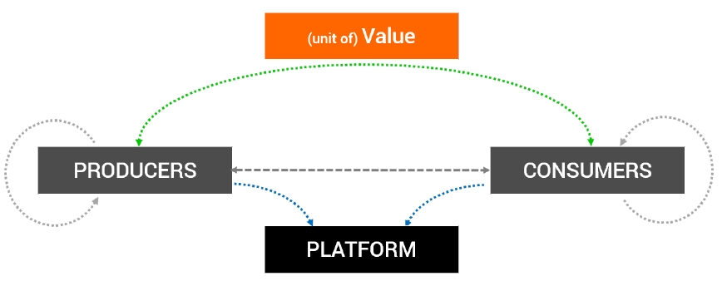

**Transactions**

Platform with two (or more) user groups provide each other with beneficial Network Effects. The stronger the more the platform increases/efficients the Interactions. It allows multiple parties to transact across the platform. Value of the platform may increase non-linearly with more users depends on strength of network effects.

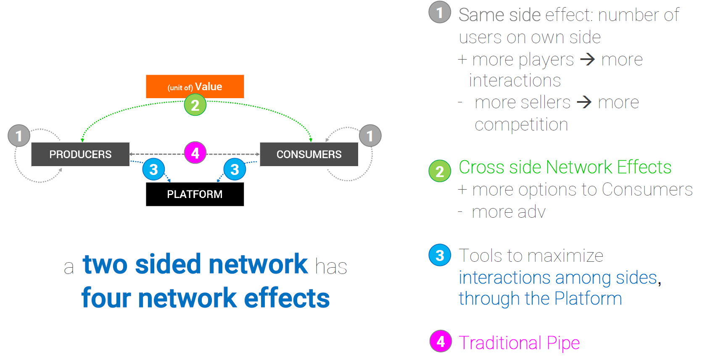

The Network Effect is an **externality**: cost or benefit incurred or received by a third party who did not choose to incur or receive that cost or benefit. Externalities can be positive (e.g. education 🡪 society benefits from it) or negative (e.g. air pollution from factories 🡪 society does not benefit from it).

The Network Effect is a phenomenon whereby a good or service value rises as more people use the platform. Platforms develop positive network effects to each of the interactions sides. Each side attracts more of the other.

**Apple iPod – platform example**

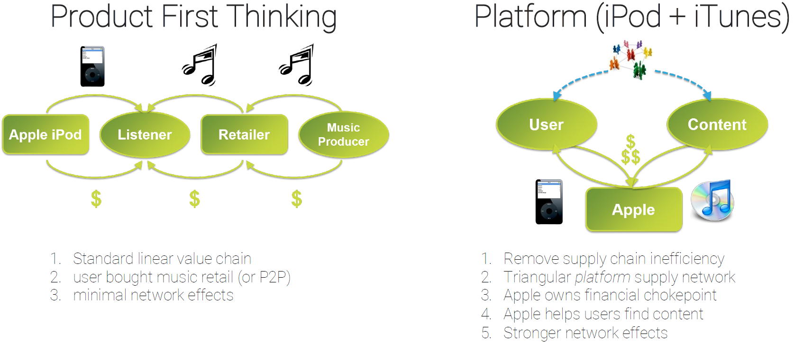

It is interesting seeing how a traditional linear BM is shaped into a platform and the above example give us the idea how to do it.

**What change: Marketing & Prices**

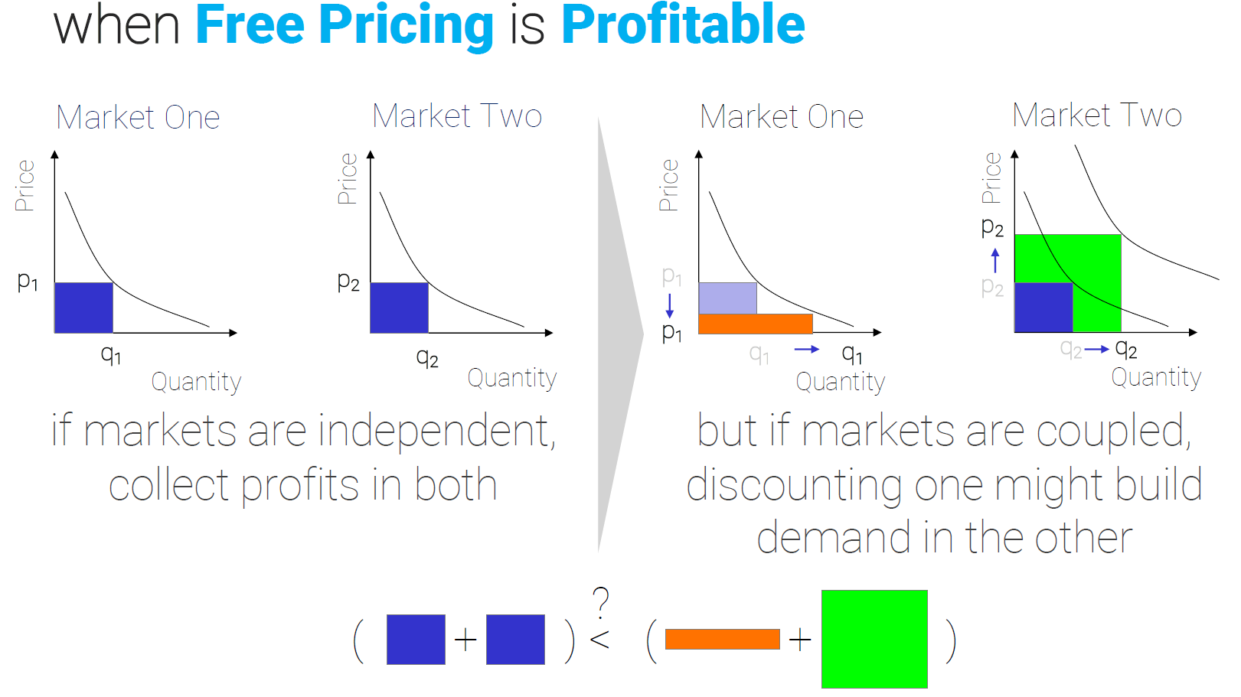

***“Instagram sold for $1B not because of contributions from 13 employees but from 30 million users***.”

Always consider the power of platforms, people love sharing contents for free. How can we do money from that? That’s the real question!

Consider this example of startup: “paper menu of restaurant are often dirty or ruined, we want to make digital menus”. Today they are selling this solution as a linear BM:

* Customers: restaurants.
* Service: menu for 100$ per year.
* Customers download the app for free.
* Activities: developing apps, restaurants.

**How can we transform this linear BM into a platform?** The app will be harder to develop (filter to adjust bad photos, automatic translations, etc.) because we want more and more customers by making more effort. When we talk about platforms, we need to do the exactly opposite of linear BM. The idea is to give the platforms for free, increasing so the number of users. But remember: being free and nice is not enough! How many people wonder to have a digital menu on their phones? Nobody. Remember the Maslow’s pyramid 🡪 what can we add to make magic our app and to convince people **installing/enter** in the app? **Number of cool guys & girls** 🡪 so stupid but it is how Facebook made billions (people engaged?).

# **7 Laboratory for the Pitch**

Pitching people is not telling your story. In this way people will not remember about you. We need to make sure people remember us. There are some tricks that we can apply. The job that we asked to do is make hypothesis, get out of the building, talk to people, Validate/Discard and repeat.

Once you have:

* Refined the Problem
* Validated the Problem
* Found a Solution
* Refined/Validated the Solution
* Analysed the Competition
* Identified your Customer
* Defined a Product
* Found a Market & Business Model
* Assembled the Best Team
* Computed Costs/Revenues
* Built a Trajectory
* Put everything in a sustainable way
* …and feel you’re ready to launch…

We are ready to go and talk to some people. In the market it is not enough to present our work as a thesis for instance, people get tired after 5 minutes. So, how can we do the best Pitch? **Pitching is a mind status not a way to do presentations!**

There is not “the Pitch” – there are, instead, several type of Pitches that real startuppers should always be ready to master:

* **Elevator Pitch**: 60 seconds, you need to convince someone in few words, extremely challenging – possibly a sentence! – very important to use popular images/brands or mental schemes. For instance, if we want to build a Google Maps for boats, using “Google Maps” to explain what we want to do is the key. “You know Nike? Something like that but …”
  + Concise: max 1-2 minutes, talking clearly and slowly (no machinegun talking). Even more challenging? A tweet!
  + Clear: no jargon, kids must understand! Don’t use technical terms!
  + Greed-Inducing: must show REAL value.
  + Irrefutable: statements MUST be irrefutable.
  + Check J <https://www.youtube.com/watch?v=Tq0tan49rmc>
* **Short Pitch**: This short form pitch typically is around 5-10 minutes long and should include some basics about your company, such as the problem you are solving, your solution, your team members, the market you are in, the competition, some financial highlights, goals you want to reach, and info on your founding team.
* **Long Pitch**: 30/20/10 Rule (we will use this one). Differently from the other types, long pitch has a structure, it gives us the time to talk about the startup in detail. It is the one that we asked to do for our project.

**The 10-20-30 Rule**: **Guy Kawasaki – 10 slides, 20 minutes, 30 point minimum font size** (<https://guykawasaki.com/the_102030_rule/>). These are the topics that you shoud cover (topics to be covered, NOT order of slides or content for each slide, this is up to you!).

* Problem (with nice introduction)
* Solution (with MVP / Demo)
* Business Model
* Underlying Magic
* Marketing / Sales
* Competition
* Team (why us?)
* Projections / Milestones
* Status / Timeline
* Call to Action: if I convince you, let’s go to action together!

All great, but how can we do that?

* **Tell your authentic story**: Enchantment: the art of changing hearts, minds and actions (G. Kawasaki, 2012): the three pillars of enchantment are likeability, trustworthiness and greatness.
* **Laptop/Smartphone off**
* **Audience First!** Who? What language should I use? What’s their story? Why are they here? Know your audience in advance!
* **Solid Structure**: Your narrative, even if simple, MUST have a structure. Something which may not be seen, but that makes the difference, giving a «fluid» touch to your speech.
* **Clear Theme a.k.a. Remove the non-essential**: Which brings to the real problem: know very well what your CORE SINGLE KEY message is. And again, knowing your Audience helps.
* **Hook them early!** Useless details and introductions will kill you. Start with an unexpected boom. Get their full attention. Do something they will remember, which, given the event, is very tough.
* **Storytelling**: Show a clear problem (remember the Hero’s Journey). Show a conflict, a struggle. Provide a clear solution, demonstrate a clear change. Show and provide passion. Your 20 minutes could be a VERY memorable moment in your life. Craft them like an artist with a masterpiece.
* **Don’t Tell – Show!**
  + Never ever make any qualitative self-made statements!
  + Use irrefutable numbers and cite verifyable sources. Always.
  + Be straight in describing the problem with numbers, graphs, data – let the numbers do the job of letting your audience understand the problem – don’t tell them!
  + The simpler the data and the infographics,the better the concept is nailed down.
  + Single listen test: an occasional listener should be able to describe your pitch perfectly after just the first listen.
* **Be Authentic**: Be yourself. Show your humanity. Superheroes are, above all, humans with their fragilities and self-doubts.

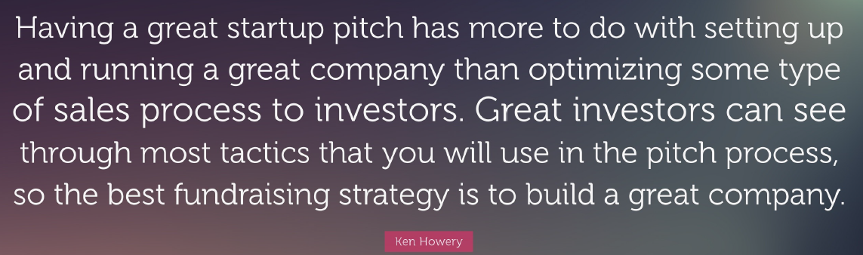

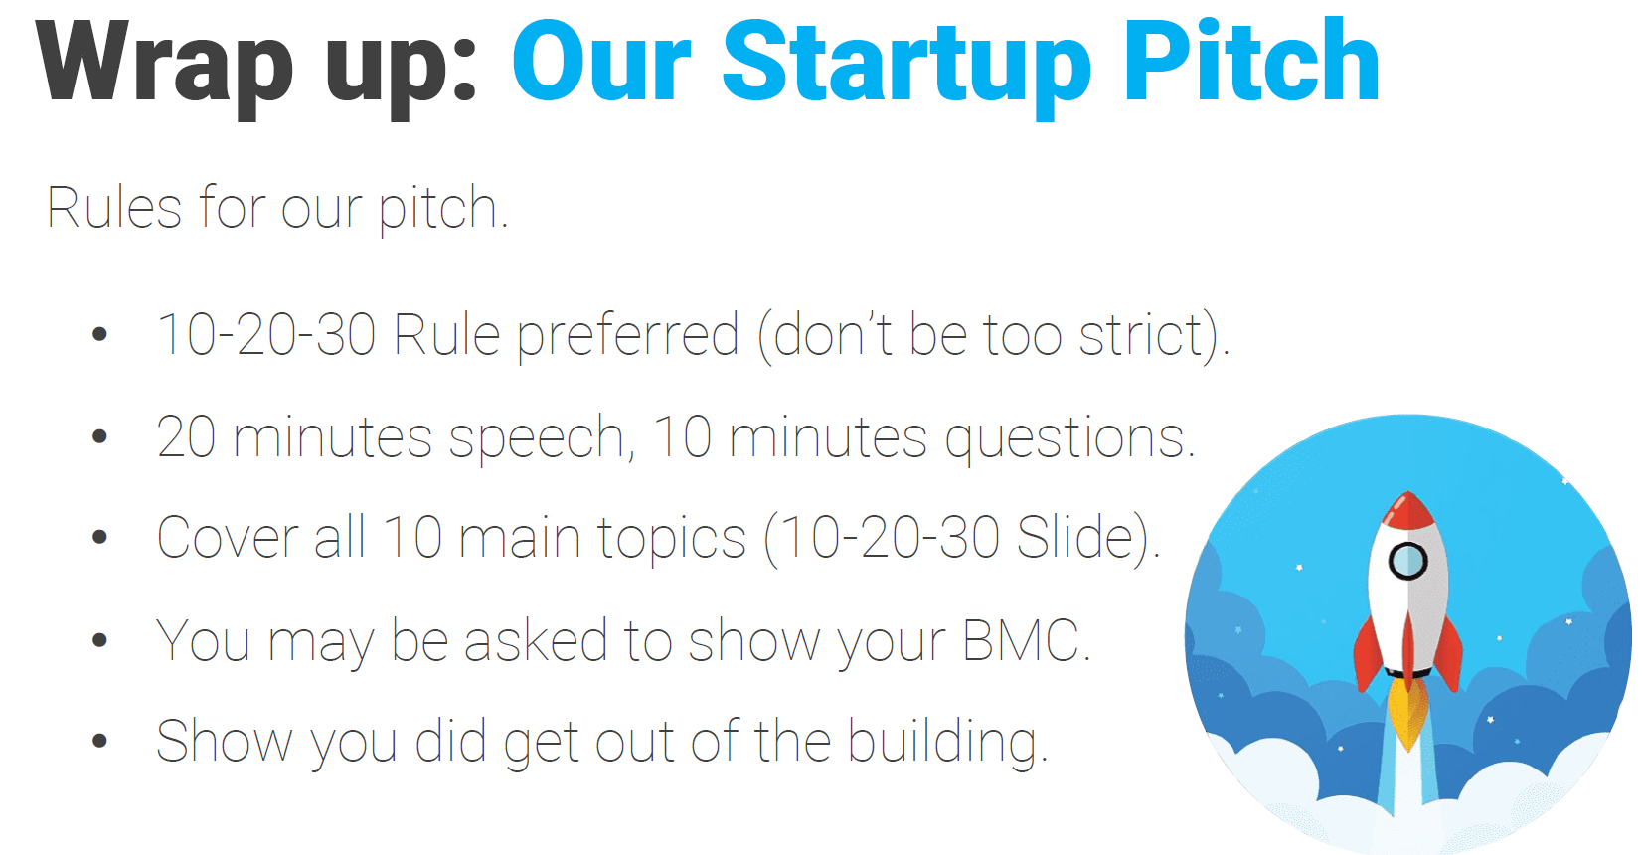

# **8 Equity**

A company can be divided into different pieces (**shares** or **stocks**). Shares involve a notary and a contract while in the stocks is like selling cars (how many cars do you want? 1,2, ..?). Both terms are strongly correlated. Who owns the biggest part of the company (shares or stocks) has the decision power. Suppose to have a company divided into three equal parts 🡪 the final decision comes from the majority of the votes so two parts voting for the same proposal and the third is out. Corporations are owned by shareholders who invest money in the business by buying shares of stock. The concept of ownership refers to legal control over a business. It gives the owner the legal right to make certain business decisions. The portion of the corporation they own depends on the percentage of stock they hold. For example, if a corporation has issued 100 shares of stock, and you own 30 shares, you own 30 percent of the company.

Typically, shareholders do not own the company, they just purchase part of the company to make money. Consider this scenario: if I am the owner, or one of the owners, of the company (NOTE: so, I am also a shareholder) and I’m not interested in the company itself, I can delegate the lead of the company to a CEO (Amministratore delegato) who manages the staff and the daily work of the company. In big companies, there are always three different kinds of people: owner(s), CEO and Staff.

**Equity**: “the value of the shares issued by a company.” or “one’s degree of ownership in any asset after all debts associated with that asset are paid off.”

The most important elements for a startup are **time share** (the time a person dedicate to a company should be recognized) and **position**. Position is defined by:

* CEO, the legal representative. He’s the one that can go to jail because he has all the responsibilities over the company.
* S/M, the sales and marketing guy
* CTO, the technical expert
* CFO, he manages the money
* Chief of marketing/sales/…, being the Chief means that there is no one above him/her.

Considering the time share and the position in defining the equity is a good approach.

**Who gets the equity?** Most important: there is not a fixed rule, every startup team will need to figure out how to structure equity and related rules since equity is one of the main “value” drivers in this stage. The followings are the ones that take the shares at the beginning of the company.

1. **Initial Founders**: they take the shares (you have the 20, 50, …). Easily 60% of the time a startup founders end up in court boils down to equity distribution issues. Dividing the shares between founders is very complicated and this, typically, does not represent the best way to do it. Possible ways to divide the shares between founders are:
   * *Even Split* – no hassles
   * ***“Future” Split***: forecast on the time / effort that one is going to provide to the company in the foreseeable future. **How do you guarantee that you will do what you say?**
   * *“Blackjack” Split*: time / effort / impact that one is going to provide to the company right now without any implication for the future.
   * Shares equal to that person’s at risk early contribution (relationships, extra time, supplies, equipment, facilities, time, money, ideas…).
   * (…and remember, founders are the few crucial key people in your startup, not only friends and valuable people who would like to take a ride…)
   * Exam question: …
   * ***Early contribution***: …
2. **Key Advisors**: Given the young and often unexperienced trait of most startup founders, Advisors are an amazing and extremely valuable source of support for startups. Some of them may dedicate a share of their time in exchange of a small portion of the equity. Key benefits: Crucial Know-how, Door Opening.
3. **Investors**: Especially at the stage of founding, there is not a general rule on the % of the company to be given to the initial investors, nor to their nature (FFF, seed investors, etc.). At the same way, at the stage of founding it is where the process of valuating your startup may be more difficult. A good advice: as always, get out of the building! Which, in this context, boils down to: talk to your peers! An investor is interested in the market not in our idea, so talk about that.
4. **Key Employees** (not to be confused with co-founders, btw): Initial startup money is often not enough to find the high value key employees needed in early stages. This is where the company shares may offer a valuable tool. Most important, as a side effect, these employees may and will not feel as employees-only and they will but a lot of extra effort to make your venture successful, since it’s, in part, their venture too!

**What’s the best way to share equity?** There is not a rule, you want to split the initial company in a way people don’t fight each other after some years. Choose an approach which is a logic one. (Look for Examples of a founder “Early Contribution” slide).

A valuable tool to manage equity among Key Employees is the **Stock options**, which is a tool that can compensate the difference between a talented figure market value and your compensation rate. Most important, they are also a tool to boost that figure involvement and effort. It allows employees to buy stocks at a discount price, keeping those figures involved and committed in the company work. The aim of a company is using this tool to keep **key** employees.

**Vesting** is the time for which employees need to wait before exercising, so acquiring, their actions. Additional mechanism which provides a long term motivator (and risk mitigator) in stock option management and will also provide to outside potential investors a clear picture of the company ownership/involvement strategy.

**If a company propose you to buy it stocks, you should fight on vesting time** (“5 years? Too many!”) **and on the exercising window** (a larger period allows to observe the behaviour of stocks and have so more choices to exercise the stock) 🡪 **the best is having shorter vesting time and longer exercising period**.

Here below the scheme of how Stock options work.



The above scheme is related to the acquisition of a single stock option but image to multiplying this scheme for 100 stock options, the payoff is huge.

# **9 Incorporate a company**

Every state in the planet has different ways to deal with companies. Furthermore, there are companies guaranteed by people and capital. If a company does something wrong someone has to pay, and that’s company. So, who is the company? Two ways to define a company:

1. **People**: take responsibilities for company’s actions, people can lose everything and go to jail.
2. **Capital**: company take responsibilities for its action, and they pay a debt. These are the most complex companies to build because building a capital company is really expensive.

In Italy there are different types of company:

* SNC (Società Nome Collettivo), SAS 🡪 to avoid at all costs. People who do not have the money to build a company may rely on these kinds but in startups environment the failure rate is really high (99%) and that’s why SNC and SAS must be avoided.
* **SRL** 🡪 the best way to build a startup. It is a kind of capital company. It is fundamental to define the “bag of money” (social capital) for every emergency or when it is necessary to manage a bad situation. The capital (C.S. or C.S.V.) must be declared by companies in their websites. In Italy, by law, the least capital is 10.000 euros, but it is even possible to put less money, even a euro! Startups with a small capital do not transmit trust so in that case it is important to transmit commitment and professional work by professional figures.
* **SPA** 🡪 even this type is suitable for startup.

Since capital company is the most suitable kind of company for startup we will deal just on it 🡪 SRL and SPA.

**How does it work within your company?** You must decide a name, the ype of company (SRL), social capital and then there are two crucial documents:

1. **Bylaws / Articles of Association** **(Statuto) (mandatory)**
   * It defines how the company works, determined by the code of law (codice civile) and further company’s laws (that are not against the code of law one) that describe how the company takes decisions (for instance 75% of weight for shareholders and 100% someone else) and works 🡪 who is the CEO, what the company does if ... 🡪 **scope of a company** (Statuto art.1).
   * **Public** (everybody can read it) 🡪 there are no names, just a set of general rules.
   * It applied to every shareholder, present and future
   * It states rules which are “by shareholder” and not nominal.
   * It needs to be written/signed by a notary who **incorporates** the company with the chose name, type of company, social capital and bylaws. After this the company is built and it can work but there is a further detail to consider.
2. **Shareholders’ Agreement** **(Patti Parasociali) (optional)**
   * It contains the real agreements between people. If those agreements are not defined nothing avoid one company’s founder to steal the idea and found his company. Basically “if you do something stupid you need to…”
   * **Private** and nominal. So private that if you ask it to a company probably it would say that it doesn’t have it.
   * Valid only between specific, well identified people, who sign the agreement personally.
   * Privately written and signed. No need for a notary.
   * NOTE: when in conflict, Bylaws have the prevalence.

These are some very important clauses in shareholders’ agreements (there are many…):

* **Put Option**: shareholder MUST be able to sell his/her stocks under condition X – or sell his/stock to specific shareholders. Put option is in favour of a person and against another.
* **Call Option**: shareholder MUST sell its stocks under condition X. The opposite of put option, I force you to sell your stocks even if you don’t agree.
* **Drag Along**: specific shareholder can trigger the call option of other shareholder when selling his/her participation.
* **Tag Along**: specific shareholder can trigger his/her put option when other shareholders are selling their participation.
* **Lockup**: time a specific shareholder must stay within the company (or specific rules trigger).
* **Good Leaver**: what happens to a shareholder that MUST leave the company involuntarily.
* **Bad Leaver**: what happens to a shareholder that chooses to leave the company voluntarily.
* **Liquidation Preference**: applies to liquidation events (some shareholders have a better selling position having their investment liquidated before the actual division of company value).

**IMPORTANT TERMS:**

* **Equity**: “the value of the shares issued by a company.” “one’s degree of ownership in any asset after all debts associated with that asset are paid off.”
* **Fair Market Value**: “the current value of the shares.”
* **Valutation**: “an estimation of something’s worth, especially one carried out by a professional appraiser”.
* **Shares**: “Shares outstanding is the total amount of shares that are held by all its shareholders.”
* **Stock Option**: “a benefit in the form of an option given by a company to an employee to buy stock in the company at a discount or at a stated fixed price.”
* **Vesting**: “Employees might be given equity in a firm but they must stay with the firm for a number of years before they are entitled to the full equity. This is a vesting provision.”

# **10 Venture Funding**

Why does a startup need funding? **Cash flow dynamics**:

* Startup costs
* Early stage losses
* Working capital (Capitale Circolante/Operativo definito come Attività Correnti – Passività Correnti)
* Cash liquidity buffer (“the money you have in your pocket”)
* R&D investments
* Inventory investments
* Customer acquisition investments
* Accelerating growth



At the beginning a startup has no money and it is fundamental to decide how to gather and spend money. When a startup starts from day 0, we start to spend money (lunches, technologies, etc). The money is fundamental for the **cash flow**, more money coming in represents a better cash flow but in startups the behaviour is different, we have a negative cash flow (just expenses) and that’s why the curve goes down following a negative financial trend at the beginning.

So, how do we get the money we need? **Raising (Risk) Capital**.

* Bootstrapping
* Friends, Family and Fools
* Business Angels
* Crowdfunding
* Grants
* Accelerators / Incubators
* Subsidies / Gov Programs
* VC, CVC

**NOTE**: **The most important thing for a startup is the type of money you take!** “Borrow money” entails giving back that money! Never borrow money from banks, they require guarantees (like your house) and if your startup fails you are fucked 🡪a startup has to guarantee a valid asset and since the rate of startup failure is still very high (95%) this is not a good way to ask money.

The main difference with the above methodologies and the bank option is that you have not to give back the money! That’s why is called risk capital, if the company goes well the risk pays otherwise not.

**SELF-FUNDING / BOOTSTRAPPING**

Some startuppers prefer to **invest their own money into the company initially**, without having to resort to other means of investment. Bootstrapping normally happens with **initial customers** supplying the startup at very specific conditions:

* The company is normally very tight on cash since **self-investments are normally low** and cover just a limited operational time.
* Startuppers putting the investment normally trade a portion of the company equity on this (but watch out for the real long-term value of such an investment).

**THE THREE FS (FFF)**

Family/Fools/Friends are often a very common way to obtain initial funding.

* No predetermined amounts even if this is normally a bootstrap amount (few k€).
* There are no rules.
* It is quite common that there is little or no need to payback such investment and they may ask for quite some unstandard conditions.
* They normally bring “only” the money.

**BUSINESS ANGELS**

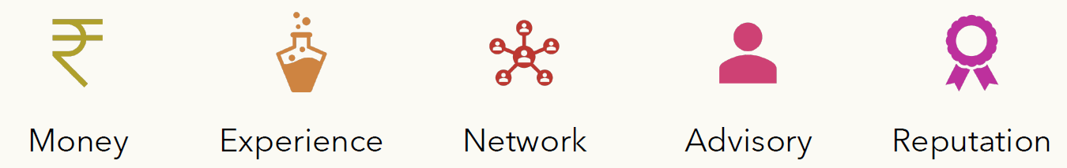

Business Angels (BA) are people with experience and capital who can give you money, they are good investors because typically they give you the money and the market.

**Business Angels Network (BAN)**: In Italy there are some of the best Business Angels Associations of Europe. Their investments fall in an approximate range between 250 K – 2 mln. In Italy in 2019 Business Angels have invested 53 million on 88 deals.

A typical behaviour is to use the first 50K to build a pretotype to show to get more money and activate the project.

How does a BAN work

* Yearly membership fee
* Investments are made through Special Purpose Vehichles
* The network creates a legal entity which hires an operative team responsible of managing:
  + The selection process (typically you send a presentation and if it is good someone will contact you)
  + The network events
  + Collect information on the investments
  + Manage the SPV’s (Special Purpose Vehicle - SPV is a special type of company that can invest on you)
  + Manage the alert levels: yellow, red

**BAN: the selection process**

1. The deck is sent to the BAN operative team which is responsible of the first screening.
2. The proposals that pass the screening are sent to members of the network who are expert of the specific areas.
3. Those proposals that are approved by the members are sent back to the operative team.
4. The operative team calls the proposers and together with the network members who chose them prepare the pitch to the assembly.
5. The pitch is presented to the assembly and soft commitments are collected.
6. If the soft commitments are sufficent to cover the required investment a champion is nominated and the negotiation starts.
7. If the negotiation ends positively, the due diligence starts.
8. If the due diligence ends positively, the investment contract and the shareholder agreement is prepared signed.
9. The SPV invests and the champion follows the investment.

**CROWDFUNDING**

Equity crowdfunding is quite different than a BAN investment.

* Backers crowdfunding (Kickstarter, Indiegogo)
* B2C
* Opening a crowdfunding campaign is **costly**
* Declining (On average, Kickstarter only achieves success at a rate of 37 percent for all the projects funded on its site.)

**VENTURE CAPITAL**

A kind of bank, some banks (or similar) combine their effort to invest a lot of money in your startup with low risk. Remember the J-curve, before reaching the breakeven point every investment is a high-risk investment (the risk tappers off reaching the breakeven point from which every investment has low risk and that’s why investing before may payoff more if the startup has success.) 🡪 Typical investment size: Early stage 500 K – 5 mln / Later stage 3 mln – 10 mln. In 2019 in Italy Venture Capital invested 597 milion Euro on 148 deals.

NOTE: the difference with BA is that business angels provide **smart money**, they follow your startup closely while venture capital are just a bank loan.

How does it work? General partners manage the fund. They own a carried interest. They share the risk by investing a small portion of the fund. Limited partners invest. They own a liquidation preference. Sometimes they can fire the fund managers.

**CORPORATE VENTURE CAPITAL**

A kind of Venture Capital but it is not managed by bankers but instead by big corporations (for instance Intel who wants to invest in a new high performing chip to arrive first to market). Big, well-established companies sometimes have their own venture capital arms that invests in startups which are aligned with their strategic goals.

* They can supply very good networking / market knowledge
* They may act as a “captive market”
* They may put some special clauses in the investment contract in order to force the alignment to their interests.
* They can supply strategic resources and partnerships which could be otherwise unreachable to a startup

**GRANTS**

A grant is a financial award for a business issued by a government, corporate, a non profit entity or other entities. They are **the only one type of free money**, they are given at the beginning of every startup (e0 looking at the J-curve).

* They are “gifts” – no need to be repaid.
* Quite/Very/Extremely competitive.
* Often requires re-aligning your strategy to the entity issuing the grant.
* There may be limits on how you use the funds.
* They may be very aligned to specific objectives (es. Green economy).

When Europe, for instance, wants to invest on grants they define the type of companies/activities to fund. There are several rules defining how a startup can get the money (for instance green startups that have … and that are …). The money is free if you respect all that rules and a contract that outlines what your startup has to do, otherwise they can ask for money back. Consider even that, since the money are free, there are several startups that fight each other to get the opportunity.

**ACCELERATORS / INCUBATORS**

They invest on the first stages of your startup to grow the company. Accelerators/Incubators teach you how to be a startupper, they fund startups in a similar way of grants, the money is almost free. Accelerators/Incubators provide their services for free (lawyers, workplace, PCs, etc). There are a lot of entities substantially investing in your startup in exchange for equity and providing initial funding and eventually other kind of support.

* They may or may not ask for equity in return.
* The funding vary (normally between 25 and few hundred k€.
* They may offer significant networking / visibility.
* They may offer formation & training / mentorship.
* They may offer incubation services.
* Sometimes you are limited to buy their services with the money they give you.

**GOVERNMENT PROGRAMS / SUBSIDIES**

There is a plethora of government programs (either at European level, national level or even regional level) or subsidies linked to very specific industries/objectives.

* Big number of programs.
* Very diverse range of investment / mechanisms – they may mix grant money and loans at very special interests.
* Will have very specific investment conditions (i.e. specific TRL).
* They may require very high effort in building the proposal or the partnership (ie with universities) and in managing the project and all records).
* They normally have tight rules and allowing conditions.

**TERMS OF INVESTMENT CONTRACTS** (not asked at the exam due to the lack of time)

In setting up investment contracts, the negotiation typically pivots around:

* Valuation (pre-money, fully diluted)
* Staged funding (when do you get the money)
* Protective rights (bad/good leaver, tag/drag, call/put, liquidation preference)
* Governance and control rights (auditor, nomination of board members, selection of the C level executives)
* Information rights (board observers)